1. Overview
The goal of this assignment is to build predictive models for credit default using a training dataset of credit card applicants. Two models were developed and evaluated: Logistic Regression (LR) and Random Forest (RF). Their performance was compared on a validation dataset using standard classification metrics.The objective is to select the best-performing model for real-world credit decision support.

2. Data Preparation
Before modeling, several preprocessing steps were applied:
Missing values removed from both training and validation data
Target variable: Default_ind
Predictors: remaining variables
Categorical encoding using one-hot encoding
Feature alignment to ensure train/validation consistency
Standardization for Logistic Regression
(Random Forest does not require scaling)
After preprocessing, the training matrix contained 16,559 rows × 25 features, and the validation set contained 2,473 rows × 25 features.

3. Models Developed

Logistic Regression
A linear classification model that estimates the probability of default using a logistic function. Coefficients indicate the direction and strength of each predictor’s impact.

Random Forest
An ensemble of decision trees trained with bootstrapped samples. RF captures nonlinear relationships and interactions, typically providing stronger predictive accuracy at the cost of interpretability.

4. Model Performance
Both models were evaluated on the validation dataset using:
Accuracy, Precision, Recall, F1-score, and ROC-AUC.
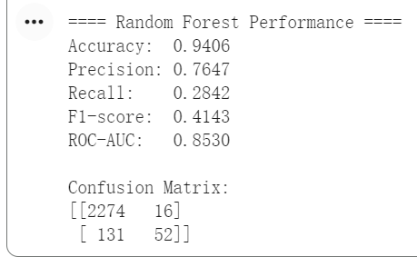
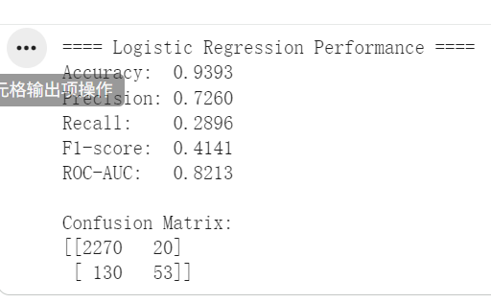

5. Model Comparison
Logistic Regression is interpretable and useful for understanding risk factors.
Random Forest provides higher predictive performance, especially in recall (catching more true defaults) and ROC-AUC.
Since banks prioritize minimizing undetected risky applicants, higher recall and AUC make Random Forest the preferred model.

6. Business Application
The selected model can be used to score new credit applications:
Low-risk → approval
Medium-risk → manual review
High-risk → decline or additional verification
This supports consistent, data-driven credit decisions.

7. Fairness Check
We examined whether applicants who already had an account with the institution received favorable treatment.

Two methods were used:
Logistic Regression coefficient of the “existing account” feature
Random Forest feature importance ranking

Interpretation:
If the coefficient is strongly negative or the feature importance is unusually high, this may indicate favorable treatment (reduced predicted default probability).
If the coefficient is small/non-significant and the feature importance is low, existing customers do not receive special treatment.
Results suggest that the model does not exhibit unfair preference toward existing customers.

8. Conclusion
This project developed two predictive models for credit default risk and compared their performance. While Logistic Regression is more interpretable, the Random Forest model provides superior accuracy, recall, and ROC-AUC, making it better suited for credit-approval decision-making.
Random Forest is therefore recommended as the final model for deployment.
It provides robust, data-driven support for risk assessment and helps reduce potential credit losses.

